# RiskProfiler Cloud Architecture

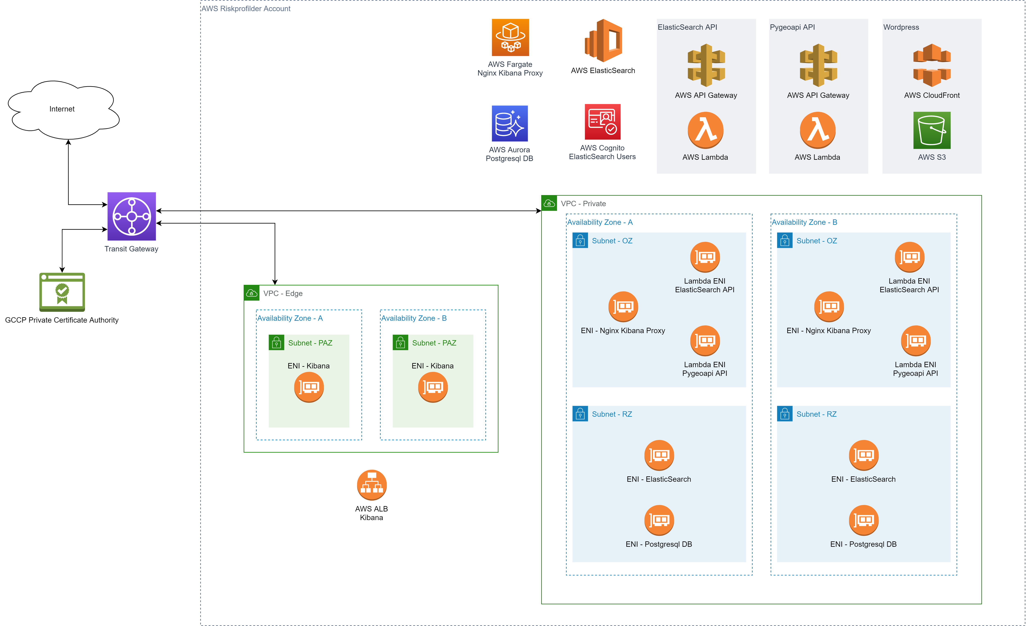

**Transit Gateway:** Deployed and managed by CIOSB. Used for routing traffic between VPCs and to the Internet.

**GCCP Private Certificate Authority:** Certificate authority server managed by GCCP. Used for getting SSL certificates for Nginx Kibana Proxy servers.

**AWS ALB Kibana:** Application Load Balancer with network interfaces deployed in Edge VPC to provide a publicly accessible Kibana dashboard. This load balancer sends incoming request to Nginx Kibana Proxy network interfaces that are deployed inside the Private VPC OZ subnets.

**AWS ElasticSearch:** AWS managed ElasticSearch Service. This service includes ElasticSearch database and Kibana dashboard. The servers that these products are deployed on are managed by AWS. The network interfaces for inbound/outbound traffic to these products are deployed in Private VPC RZ subnets.

**AWS Cognito ElasticSearch Users:** AWS user management service integrated with ElasticSearch to provide authentication using OAuth.

**AWS Fargate Nginx Kibana Proxy:** AWS container service for running Nginx as proxy to access Kibana dashboard. The servers for running Docker containers are managed by AWS. The network interfaces for inbound/outbound traffic to Nginx servers are deployed in the Private VPC OZ subnet. The AWS ALB Kibana forwards the incoming traffic to Nginx network interfaces.

**ElasticSearch API:** Consists of two AWS services (API Gateway and Lambda) to provide a publicly accessible API for querying ElasticSearch data. API Gateway forwards the incoming requests to AWS Lambda which acts as a proxy layer to ElasticSearch. The network interfaces for Lambda are deployed in the Private VPC OZ subnets to enable secure communication with ElasticSearch.

**Pygeoapi API:** Consists of two AWS services (API Gateway and Lambda) as a serverless solution for Pygeoapi application. The application itself runs as a Lambda function. It uses ElasticSearch as a data provider and the communication is done through the Lambda network interfaces that are deployed in the Private VPC OZ subnets.

**AWS Aurora Postgresql DB:** AWS serverless Postgresql database. The data in this database is only being used for populating indices in ElasticSearch using scripts that extract and process the data. The network interfaces for this database are deployed in Private VPC RZ subnets.

**Wordpress:** Wordpress is deployed as a static website. The files are hosted on a S3 bucket and are served securely through CloudFront.

# Public Endpoint

|  |  |  |  |
| --- | --- | --- | --- |
| Environment | Dev | Stage | Prod |
| Pygeoapi API | <https://geo-api.dev.riskprofiler.ca> | <https://geo-api.stage.riskprofiler.ca> | <https://geo-api.riskprofiler.ca> |
| ElasticSearch API | <https://api.dev.riskprofiler.ca> | <https://api.stage.riskprofiler.ca> | <https://api.riskprofiler.ca> |
| Kibana Dashboard | <https://dashboard.dev.riskprofiler.ca> | <https://dashboard.stage.riskprofiler.ca> | <https://dashboard.riskprofiler.ca> |
| Wordpress | <https://dev.riskprofiler.ca> | <https://stage.riskprofiler.ca> | <https://riskprofiler.ca> |